# Data Centric RAD

## Lab 9 JSF Introduction

### Setting up a JSF Project

* Open Eclipse Java EE IDE for Web Developers.
* Select *File/New/Other/Web/Dynamic Web Project*.
* Enter a project name and select the Target runtime as shown:

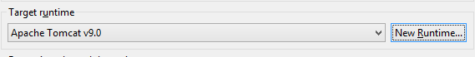

* + If there are no options, press *New Runtime*
  + Click on Apache Tomcat v9.0 and press *Next*
  + Browse to the Apache Tomcat installation directory and press *Finish*

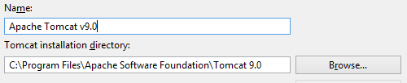

* Press *Modify* in the Configuration section:

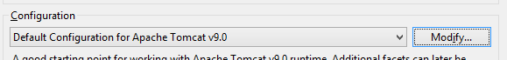

* On the *Project Facets* window select JavaServer Faces 2.2 and press *OK*.

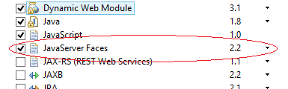

* Press *Next* until the *Web Module* screen appears, select the *Generate web.xml deployment descriptor* and press *Next*.

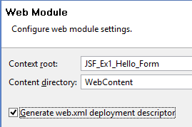

* On the *JSF Capabilities* screen, press the *Download library* button.

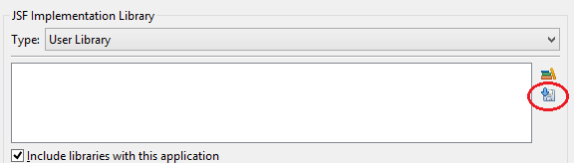

* Select the *JSF 2.2* screen, then press the *Next* followed by *Finish*.

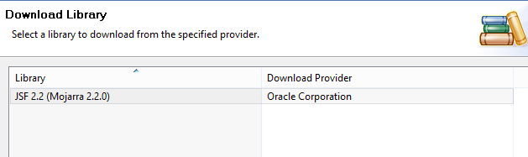

* Press *Finish* on the *JSF Capabilities* window.
* The Dynamic Web Application project has now been created.

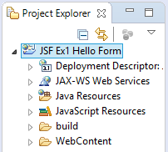

* In the Windows File Explorer, navigate to the project you just created and create a folder called *lib*, so that your project now looks as follows:

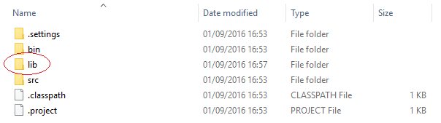

* Download the MySQL driver from <https://dev.mysql.com/downloads/connector/j/>.
* After unzipping the file, copy mysql-connector-java-5.1.39-bin.jar to the *lib* folder previously created.
* In Eclipse, select the project you just created and then select *Project/Properties*.
* Click on *Java Build Path*, then the *Libraries* tab, then press the *Add External JARs…*
* Select the mysql-connector-java-5.1.39-bin.jar file in the lib directory of the project and press *Open.*
* When the mysql-connector-java-5.1.39-bin.jar appears on the build path (see below) press OK.

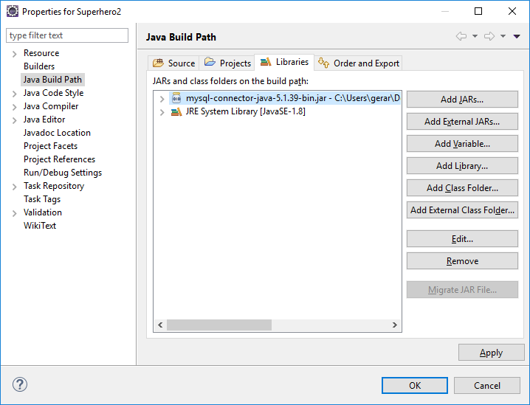

* To run each exercise below, select the main .xhtml file and select *Run/Run As/Run on Server* in Eclipse.

### Part 1 JSF Student Details Form

* Write a JSF web application that allows a Student to enter the following details
  + First Name (The input field should say *First Name*)
  + Surname (The input field should say *Surname*)
  + Address (The input field should allow multiple lines)
  + Phone Number
  + Age
  + Sex (Male and Female should be radio buttons)

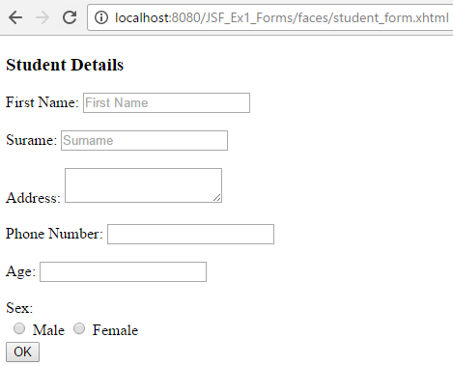

When the user enters his/her details and presses *OK*, for example as follows:

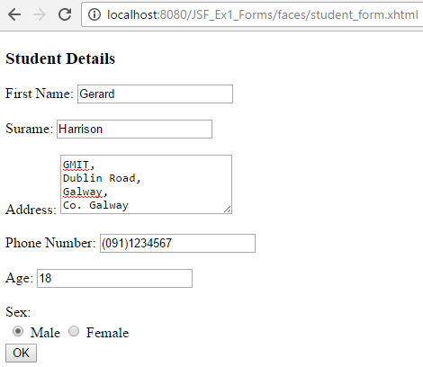

Another web page should display his/her details as follows:

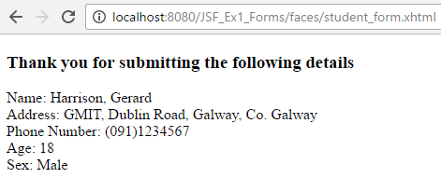

### Part 2 JSF Student Details Form

* Update Part 1 to include a cancel button on the student registration form:

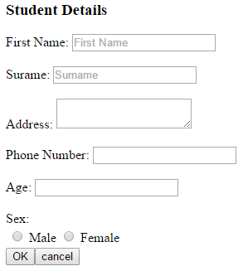

If the cancel button is pressed a new web page should display a message and a link to get back to the student registration form:

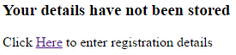

### Part 3 JSF Student Details Form with ManagedBean

* Update Part 2 to have a ManagedBean called *Student* with the following properties:
  + **private** String firstName;
  + **private** String surname;
  + **private** String address;
  + **private** String phone;
  + **private** **int** age;
  + **private** String sex;
  + **private** **int** yearBorn;

Any of these properties entered on the form should be stored in the ManagedBean and any properties displayed should be read from the ManagedBean.

The *Male* radio button should be the default button selected when the form appears.

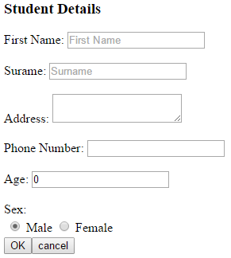

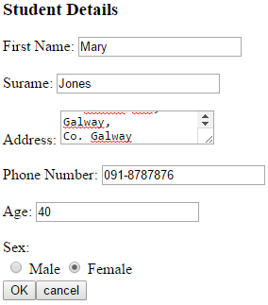

When the user presses OK his/her details should be displayed as follows.

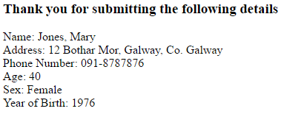

### Part 4 JSF Student Details Form with Drop Down Menu and ManagedBean

* Update Part 3 to include two drop down menus one of which should allow the user to choose his/her country:

|  |  |
| --- | --- |
| Value used in Code | Value Displayed to User |
| IRL | Ireland |
| UK | United Kingdom |
| FRA | France |
| GER | Germany |
| SPA | Spain |
| USA | United States of America |
| OTH | Other… |

The other should allow the user to choose his/her course:

|  |  |
| --- | --- |
| Value used in Code | Value Displayed to User |
| BSC | B.Sc. in Computing and Software Development |
| BSCHONS | B.Sc. (Hons) in Computing and Software Development |

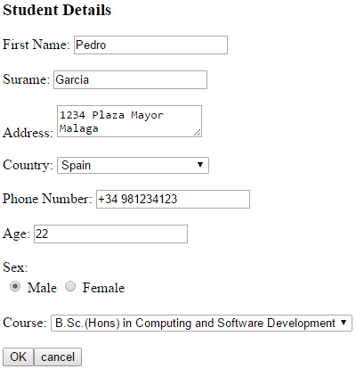

When the user presses *OK* the full country name and the Expected Year of Graduation should be displayed.

(If a user choose the course “B.Sc. in Computing and Software Development” his/her Expected Year of Graduation should be 3 years after the current year.

If a user choose the course “B.Sc. (HONS) in Computing and Software Development” his/her Expected Year of Graduation should be 4 years after the current year.):

